P2 Django She Codes News

# Repository link:

[<https://github.com/alisonvpereira/P3-She-Codes-News>](https://github.com/alisonvpereira/P3-She-Codes-News)

# Functional login/logout buttons

|  |  |
| --- | --- |
| Nav bar before log in | nav bar after log in |
|  |  |

Authentication only goes as far as requiring a log in. No additional configuration prevents users from accessing and editing other user’s profiles or stories (yet).

# Account view so authors can see their profile information

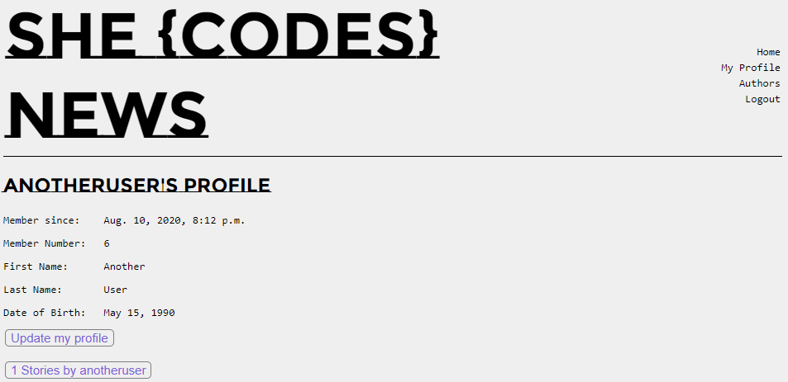

# Create Account functionality, so a new user can sign up to be an author.

Create new story button visible before log in but once clicked, prompts the user to log in or create an account.

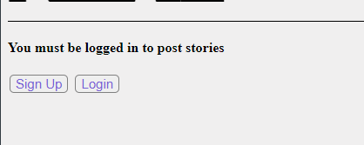

|  |  |
| --- | --- |
| Sign Up screen | Log in screen |
|  |  |

# View stories by a particular author

Author’s button on Nav bar displays a list of active authors and a count of stories (Published + Draft) for each. Each row takes the user to that authors’ profile where another button takes you to that author’s published story list. Could not figure out how to get the “count” to calculate filtered by status=PUBLISH.

|  |  |  |
| --- | --- | --- |
|  |  |  |
|  |  |  |

# Enabled story edit for own stories

Could not figure out how to disable editing for all stories when logged in.

|  |  |
| --- | --- |
| View for stories published by other authors | View for own stories |
|  |  |
|  |  |

# Add categories to the stories and allow the user to search for stories by category

Added a functional Category field to all stories but did not set up a search

